Online Shopping System: FootFusion

Use-Case-Realization Specification: View Products

Version <1.0>

Revision History
Date | Version | Description | Author
28/11/2024 | 1.0 | Final Draft | Doan Thi Phuong Hong

Table of Contents
1. Introduction 4
1.1 Purpose 4
1.2 Scope 4
1.3 Definitions, Acronyms, and Abbreviations 4
1.4 References 4
1.5 Overview 4
2. Flow of Events—Design 4
2.1 Sequence diagram 4
2.2 Class diagram 5
3. Derived Requirements 5

Use-Case-Realization Specification: View Products

Introduction

Purpose
This document outlines the realization of the "View Products" use case in the design model, focusing on the interactions between collaborating objects.

Scope
This document pertains to FootFusion, an online shopping platform.

Definitions, Acronyms, and Abbreviations
Buyer: A user using the FootFusion application to browse and purchase products.

References
Use Case Specification – View Products

Overview
This document describes the Use-Case Realization Specification for the "View Products" use case in the FootFusion system. It begins with a textual description of the use case specification. Following that, a sequence diagram illustrates how the use case is realized through interactions between collaborating objects, and a class diagram depicts the relationships of the participating classes. The final section analyzes additional requirements, including non-functional ones, that are not part of the design model but must be addressed during implementation.

Flow of Events—Design
Buyer views products available in the store through the system.

Sequence diagram

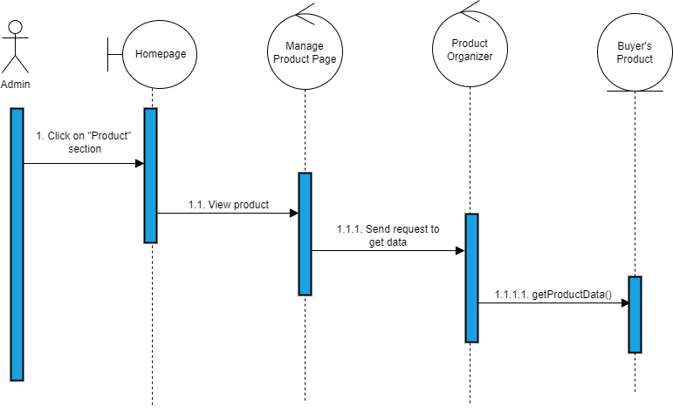

Class diagram
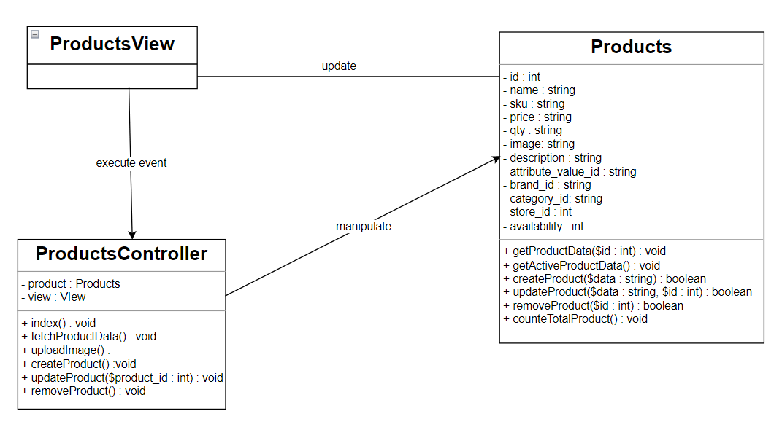

Derived Requirements
There is no derived requirement.

